**Decoder Tutorial**

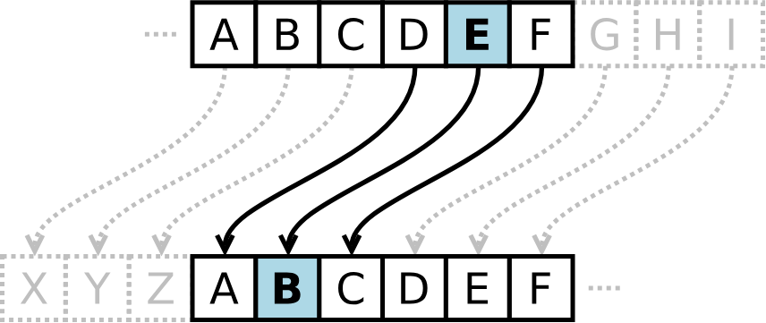

Imagine we have two corresponding alphabets, one representing our true text, and the other representing the encrypted message. In a Caesar cipher, a number is chosen to represent the **offset** between the alphabets of the encrypted message and the true text. For example, the offset number may be +2, which represents a shift of the encrypted alphabet forward 2 letters. The encrypted alphabet would begin with C. Likewise, a shift of -2 would shift the alphabet back twice, meaning the encrypted alphabet would begin with Y.

On our included cipher, the outside alphabet represents the encrypted text, and the inside alphabet corresponds to the true, decrypted text. 

